September 30, 2025
Ref: IIH/MD/2025/09/023

The Honourable Commissioner
Ministry of Business, Innovation and Technology
Sulu Gambari Road,
GRA, Ilorin,
Kwara State
Dear Honourable Commissioner,
CLARIFICATION ON INCORPORATION AND NAME CHANGE OF ILORIN INNOVATION HUB
We write to provide clarity on the legal entity operating the Ilorin Innovation Hub.
The Hub was originally incorporated at the Corporate Affairs Commission (CAC) on 4th March 2020 as Ilorin Innovation Hub Ltd under RC No. 1664691, with Harmony Holdings Ltd (HHL) as the parent entity. This entity is a private limited company limited by shares has since remained the sole vehicle for the operation and management of the Hub.
On 17th March 2025, a special resolution was passed to change the company’s name from Ilorin Innovation Hub Ltd to Ilorin Tech Park Ltd (same RC No. 1664691). The purpose of this change was to free up the name Ilorin Innovation Hub for use in registering a new non-profit organisation (Ltd/Gte – limited by guarantee not shares) in line with our strategic partnership with IHS Towers, which requires this private, nonprofit NGO structure for programmatic and funding purposes. This is because no two entities with the CAC can bear the same name even if they are not of the same type.
We wish to emphasize that Ilorin Tech Park Ltd (formerly Ilorin Innovation Hub Ltd) remains the same incorporated entity registered in 2020 and continues to be our sole operating company for the management of the Hub’s facilities and operations. The new NGO registration is a complementary vehicle intended strictly for program partnerships and not a replacement of the existing company.
For ease of reference, attached are copies of:
- The original Certificate of Incorporation (Ilorin Innovation Hub Ltd, March 2020).
- The Certificate of Change of Name (Ilorin Tech Park Ltd, March 2025).
We trust this provides the necessary clarification, and we remain available to provide further documentation or briefing if required. Thank you for your continued support.
Yours sincerely,
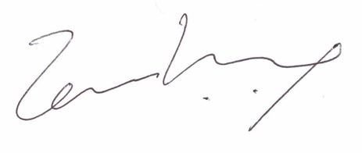
Temi Kolawole
Managing Director

